###### Who is look up :Who is look up : WHOIS is a protocol used query databases(RIR’s) that store information about the registered users of an internet resource, known as domain name and IP address block.

**Using WHOIS Protocol :** Information gathering on different sites.

**Target Site :** GoDaddy.com

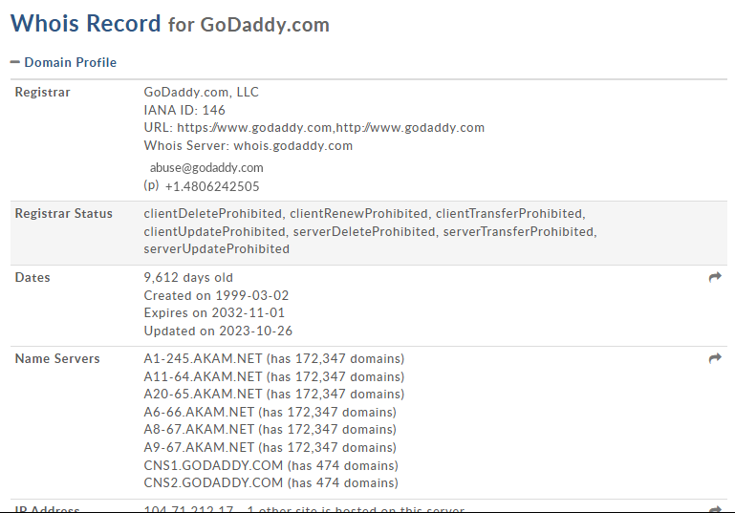

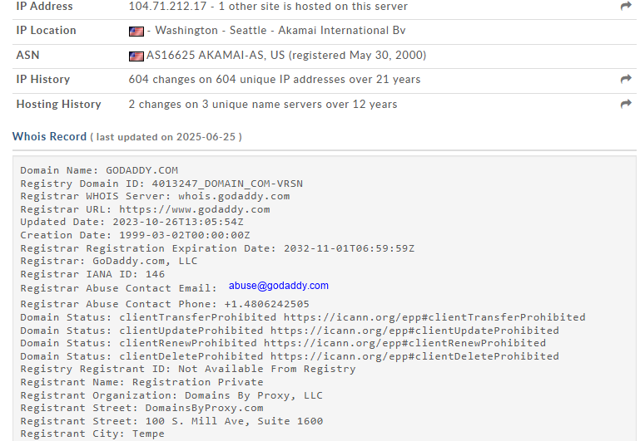

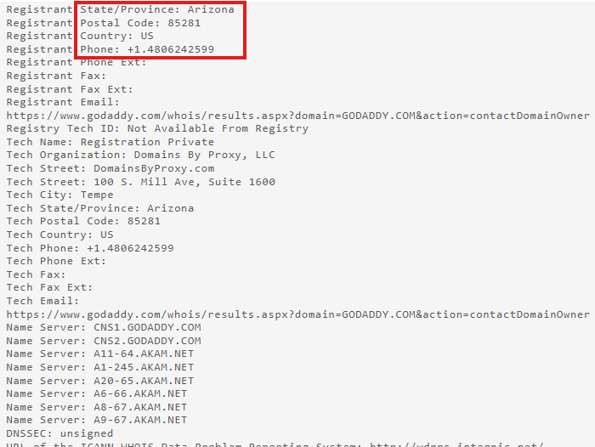

**Target Site :** HARSHTRAININGS.COM

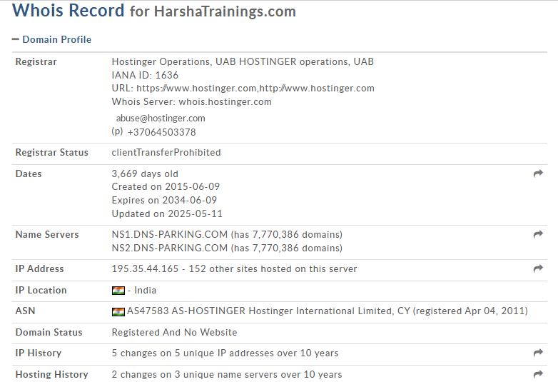

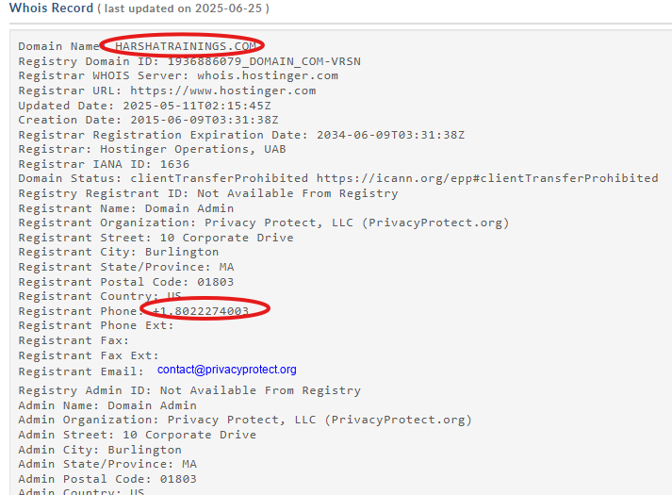

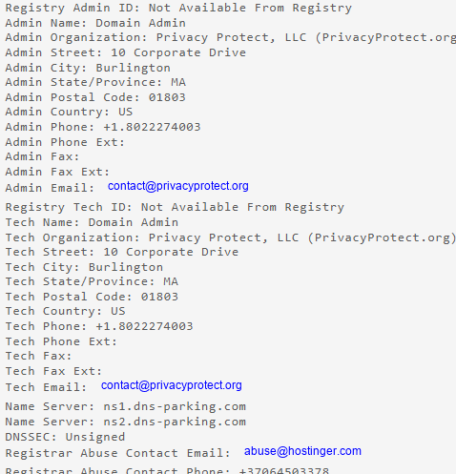

**Target Site :** ONLINESBI.SBI

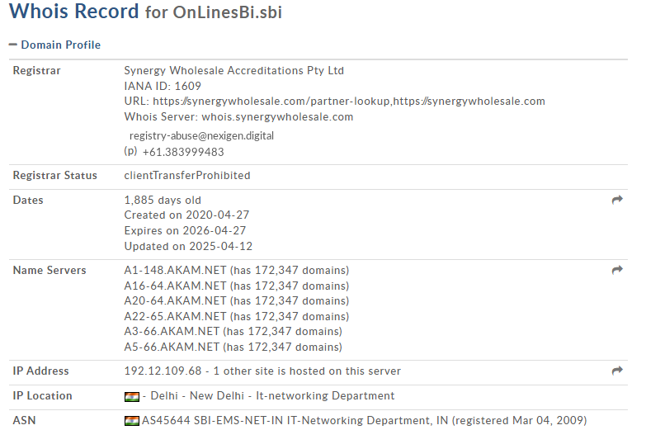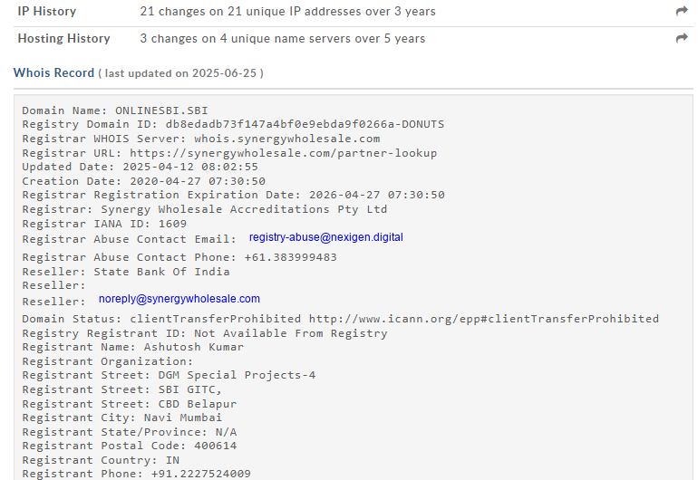

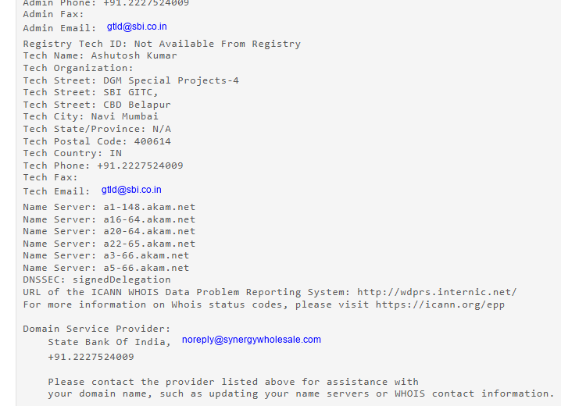

**SUMMARY :**

By using this protocol we have got additional information like when the organization registered its domain and when it will expire, hosting servers, status etc.